 CHEMICAL ENGINEERING TRANSACTIONS  VOL. xxx, 2024 | A publication of  
The Italian Association
of Chemical Engineering
Online at www.cetjournal.it

Guest Editors: Valerio Cozzani, Bruno Fabiano, Genserik Reniers
Copyright © 2024, AIDIC Servizi S.r.l.
ISBN 979-12-81206-11-3; ISSN 2283-9216

Myths and Misinformation on the Repurposing of Natural Gas Grids for Hydrogen
Andrews G.E.^{a,b,*}, Phylaktou H.Nª, Quinonez R.^{b}, Maxfield J.^{b}, Wakeman R.^{b}, Smith, S.^{b}
ª University of Leeds, School of Chemical and Process Engineering, Leeds, LS2 9JT
^{b} Clean Burner Systems Ltd., CBS, 11 Caputhall Road, Deans Industrial Estate, Livingston, EH54 8AS
corresponding:.profegeandrews@hotmail.com

This review aims to dispel the myths, misinformation and fake facts about hydrogen burner flames in the literature and on the internet. These are creating resistance the adoption of hydrogen for decarbonising heat. Trials of hydrogen heat in hydrogen villages have been opposed in the UK by outside groups generating unsubstantiated fears about the safety of the use of hydrogen and influencing Government policy on the decarbonisation of domestic and industrial heat. There are many myths about the use of hydrogen for heat (Hy4Heat), most of which relate to safety, which ignore all the work done under UK Government Hy4Heat contracts, that show that hydrogen will be as safe as natural gas (NG) in use, in domestic and industrial heat applications. Some claim that the manufacture of hydrogen from NG will generate more greenhouse gases (GHG) than burning it directly (Rosenow, 2022), which is not true for modern low emissions plants (Al Ghafri SZS et al., 2022), that are the only ones that would be allowed to be built. Domestic and industrial electricity is delivered by the electricity grid, which currently cannot operate without 40% of the electricity from NG fired combined cycle gas turbines (CCGT), as this fills in the supply gaps when the wind is low and the sky cloudy. This means that electric heat pumps are not zero carbon and have higher carbon emssions than hydrogen made from NG using the latest technology. In contrast hydrogen, can be manufactured from NG or by electrolysis directly by solar and wind farms, without any connection to the electricity grid and fed into the gas transmission system, with only relatively low cost modifications. Hydrogen burners can be designed to meet all current NO_{x} standards and even have lower NO_{x} than on NG and will not be allowed to emit higher NO_{x} than for NG. Practical hydrogen burners for heat applications have orange flames and very visible not invisible, as many in the literature claim. The UK and other countries in 1900 - 1965 built coal gasification plants on a large scale to feed the gas grid with coal gas (about 40% hydrogen), then replaced the gas with natural gas in the 1965 – 1975 period, fuel switching to hydrogen is conventional gas engineering and achievable over a 10-15 year period. In the UK the gas grid in 2022 supplied 784TWh of energy compared with 320 TWh of electricity with only 99 TWh of this from solar/wind/hydro. It is obviously grossly misleading to say that gas energy can be replaced by increased solar/wind/hydro on any sensible timescale. Switching the 300 TWh of domestic heat from gas to electricity in addition to switching transport energy to electricity, cannot be met on the required timescale by increased solar/wind/hydro in the UK and most other European countries. Net zero can be met on a 10-15 year timescale if NG is switched to hydrogen, which enables net zero electricity, as well as net zero heat.
  - Introduction
There is a vociferous anti-hydrogen lobby (HyNot, 2022; Rosenow, 2022) that has been very successful in persuading UK Government Policy makers and the residents of proposed UK hydrogen villages, that the future of domestic heat should not be hydrogen, but should be electric heat pumps (IEA, 2021). Heat pumps are a good technology, producing on average 2.7 times the heat energy of the electrical energy consumed (Rosenow, 2022). However, the UK had in 2023 39,268 Microgeneration Certification Scheme (MCS) certified heat pump installations. At this installation rate it would take 760 years for all 30M dwellings in the UK to have heat pumps, whereas gas installations of boilers is 1.6M per year with 0.25M gas fires and these could be easily converted to hydrogen operation, with similar installation rates and at a much lower cost to the consumer. The reality is that heat pumps are not a solution to decarbonisation, no matter how good the technology is, if most homes cannot afford to buy and install them.
There are three problems with heat pumps: firstly they have to be connected to the electricity supply grid, where the electricity used is not zero carbon and was 186 g/kWh in 2022 (DESNZ, 2023) and higher in most European countries; they are too expensive for most people to buy and install (about £15,000 compared with £3,000 for a gas boiler and £250 for a gas fire); and there is not enough wind/solar/hydro electricity generated for every household to operate heat pumps or any other cheaper electrical heaters. In 2022 255 TWh of gas was used for domestic heat, 33% of the 784 TWh of total gas use (DESNZ, 2023), which would require at least 85 TWh of electricity for the same heat from heat pumps. This is just below all domestic electricity supplied in 2022 (96.2 TWh) and solar/wind/hydro green electricity was 99 TWh. This is additional to supplying electricity for electric cars which will add about 100TWh of green electricity demand, if we all drive electric cars after 2035.
Currently, electricity use in the UK is 305 TWh and to add domestic heat and electric cars will increase this to about 490 TWh. This requires about five times the current solar/wind/hydro electricity, if net zero is to be met. It is impossible for the grid to supply this increase without a massive programme of new green electricity generation and grid reinforcement. As there are no policies to deliver the required 5 times existing solar/wind/hydro and the required grid expansion and no way of financing this, other than through increased charges to customers, in reality net zero electricity will not be delivered and there will be little reduction in domestic heat carbon emissions. The UK had no bids for the 2023 round of offshore wind farm licenses and the guaranteed price had to be increased substantially in 2024 to get new offshore wind farm offers. UK electricity was 3.2 times the price of gas in 2022 and this is set to rise in the future as ever more expensive zero carbon electricity is connected to the grid. Heat pumps will cost the consumer more to operate than gas as well as much more to purchase, for the same heat output. If a wholly electric solution to domestic heat and passenger car transport is forced on consumers by closing the gas grid, this will exacerbate fuel poverty and increase deaths from cold in Winter, as there will be no low cost gas fires to use.
The obvious route out of this lack of sufficient solar/wind/hydro electricity is to utilise the existing gas grid and repurpose it for hydrogen, so that it can continue to deliver 784 TWh of energy, some of which will be used in CCGTs to balance variable wind and solar generation and thus help the electricity grid to achieve net zero. 40% of UK electricity was from gas in 2022 (DESNZ, 2023). If hydrogen is manufactured using electricity via electrolysis, this does not help, as the burden is still there on the electricity supply. Only if wind and solar farms, not connected to the electricity grid are used to manufacture hydrogen for distribution in the gas grid, which has the capacity to distribute the energy, will the decarbonisation of heat and electricity be achieved. The electricity grid does not have the capacity for the required x5 increase in electricity delivered from new wind and solar installations, but the gas grid does have the capacity to deliver the equivalent hydrogen heat energy, as well as generating zero carbon electricity using existing and new CCGTs converted for hydrogen operation.
Manufacturing hydrogen from NG with CCS is a viable route to very low carbon emissions, with <20g_{CO2}/MJ (<72 g_{CO2}/kWh) the UK standard (Taylor, 2021) and <5 g/MJ available from the best technology (AlGhafri et al., 2022). The IEA (2021) envisage that hydrogen will be manufactured from NG initially, with electrolysis coming more important once the large increase in solar/wind/hydro electricity has been delivered. As heat pumps are run on grid electricity, they generate a share of the grid 186 g_{CO2}/kWh. For 2.7 units of heat delivered on average from 1 unit of electricity by heat pumps, the 255 TWh of domestic gas used for heat will require 94 TWh of additional electricity. If heat pumps replace gas heating they will have 51.7 g_{CO2} /MJ, much higher than will be allowed for hydrogen generated from NG. Heat pumps do not make sense as a route to zero carbon emissions.
Fake Fact 1 is that hydrogen manufacture from NG will generate more GHGs than burning the NG directly for heat (HyNot, 2022; Rosenow, 2022), whereas at present in the UK it is heat pumps that will generate more GHGs than hydrogen from NG, as the grid electricity used is not zero carbon and cannot be zero until the NG used in CCGTs is replaced by hydrogen or new pumped storage hydro-electricity.
Hydrogen is the most practical and cost effective route to decarbonise domestic and industrial heat for the 25M houses connected to the gas grid. It uses the £300bn+ infrastructure investment by consumers in the gas grid over the last 100 years. Heat pumps should be used in the ~6M houses not connected to the gas grid in the UK. The UK has the largest gas grid in the World relative to it’s population (80% of homes heated by gas). Most European countries also have significant gas grids, Germany has 48% of apartments connected to gas, as does the USA with 47% of houses connected. Not to use this valuable energy distribution asset, which some advocate (HyNOT,2022; Rosenow, 2022), is a waste of one of the UK’s largest and most valuable infrastructure assets, that was paid for since 1990 by the gas consumers. T
The investment in the gas grid is ongoing, as local distribution pipes are being changed from cast iron to polyethylene (PE), which is also required for hydrogen distribution. The gas supply industry was in 2004 given about 30 years to undertake this gas grid infrastructure upgrade, as part of the GHG reduction policy to stop NG leaks, which will have cost about £100bn when completed. Not to use it for hydrogen is a major policy mistake that will ensure that the UK cannot meet its net zero ambitions. The cost of the PE pipe installations is around £100 per consumer per year now and Patel et al. (2022) have estimated the annual cost per household of hydrogen above that of NG would be £50 if made from NG and £137 if made from wind/solar/hydro. Thus, as
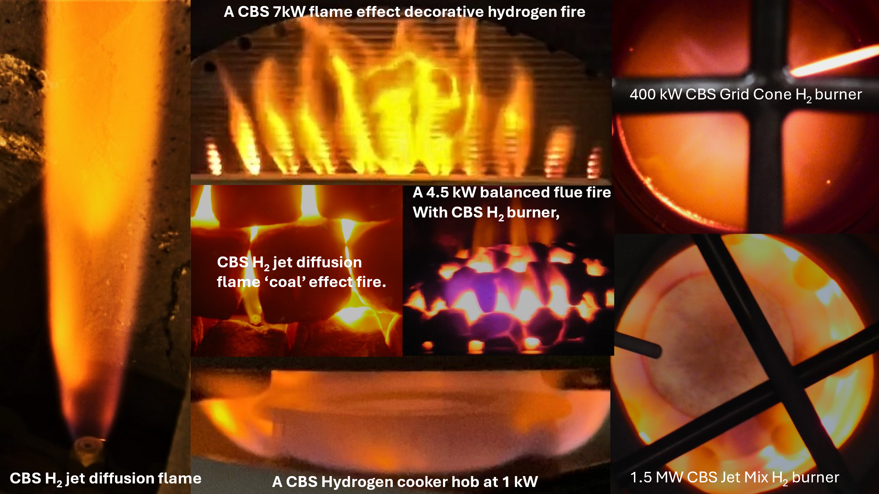

Figure 1: Seven CBS hydrogen burner orange flames from a 1 kW hob burner to a 1.5 MW process burner.

the PE pipe installation programme ends in 2032 and hydrogen manufacture on a large scale will start in about 2027, it is likely that the customer would see little change in these infrastructure payments for hydrogen conversion.
Thus, those advocating the closure of the gas grid are likely to prevent net zero from being achieved. Publicising false information about hydrogen, particularly in relation to safety and emissions increases, are tools that the anti-hydrogen lobbyist are using (HyNot, 2022; Rosenow, 2022; Baxter, 2022).
  - Hydrogen Diffusion Flames are clearly visible and orange NOT invisible. (Fake Fact 2)
If hydrogen flames on real burners were invisible, particularly for cooker hobs, then this would be a safety issue. Fortunately, this is not the case but there are lots of publications and online sites that say hydrogen flames are invisible. Hydrogen diffusion burner flames are visible and orange, as shown in the seven CBS hydrogen burner flames in Fig.1, from a 1 kW cooker hob burner to a 1.5MW industrial CBS Jet Mix burner. Other investigators of industrial hydrogen burners have also found the flames are orange. Mohanna et al. have shown for a 350kW direct fired furnace (DFF) hydrogen burner, with flameless combustion, that the flame was orange. Lowe et al. investigated a 15MW low NO_{x} process heater burner on NG and hydrogen and the flame was blue on NG and orange on hydrogen. That hydrogen diffusion flames are orange is known by every school science teacher and hopefully their pupils, as the action of sulphuric acid on zinc to produce hydrogen, is a common school science experiment. The hydrogen gas is collected in a glass vessel and then released so it rises under buoyancy and is then ignited to produce an orange ball of flame. The oldest reference to the ‘reddish brown’ colour of hydrogen flames is by Barrett (1872) and the classic work of Hawthorne, Weddell and Hottel (1949) measured the ‘visible’ length of hydrogen diffusion flames, which Fig. 1 shows on the LHS are visible and orange.
The Fake Fact 2 that hydrogen flames have no or low visibility was also in a UK Government funded review (Livermore et al., 2018) without a primary reference for the statement ‘hydrogen burns with a pale blue flame that is difficult to see in daylight conditions’. The report included a hydrogen flame photograph from a production domestic burner that was clearly visible with staged colouring of blue and orange! They went on to advocate that all hydrogen flames would need a colourant adding to make the flame visible!
Clatti et al. (2007) have measured the radiation spectrum from a premixed hydrogen engine flame with an OH peak and a broad peak at the 700nm of red colour, caused by hot water vapour emissions. Also, in diffusion flames the central unburnt hydrogen, which exists for at least 20 diffusion jet diameters (Weddell et al., 1949), is heated by the surrounding flame and hot hydrogen radiates at 656nm in the orange region. A common burner design technique for low NO_{x} emissions is rich/lean aerodynamically staged combustion, used in all the hydrogen flames in Fig. 1, which creates the rich zones by aerodynamic air staging giving the orange colour.
Schafer et al. (2009) investigated the common misconception that hydrogen flames are not visible. They comment that visitors to the Combustion Research Facility at Sandia National Labs express surprise when they discovered that hydrogen flames are visible. Detailed flame spectra were presented to characterize flame
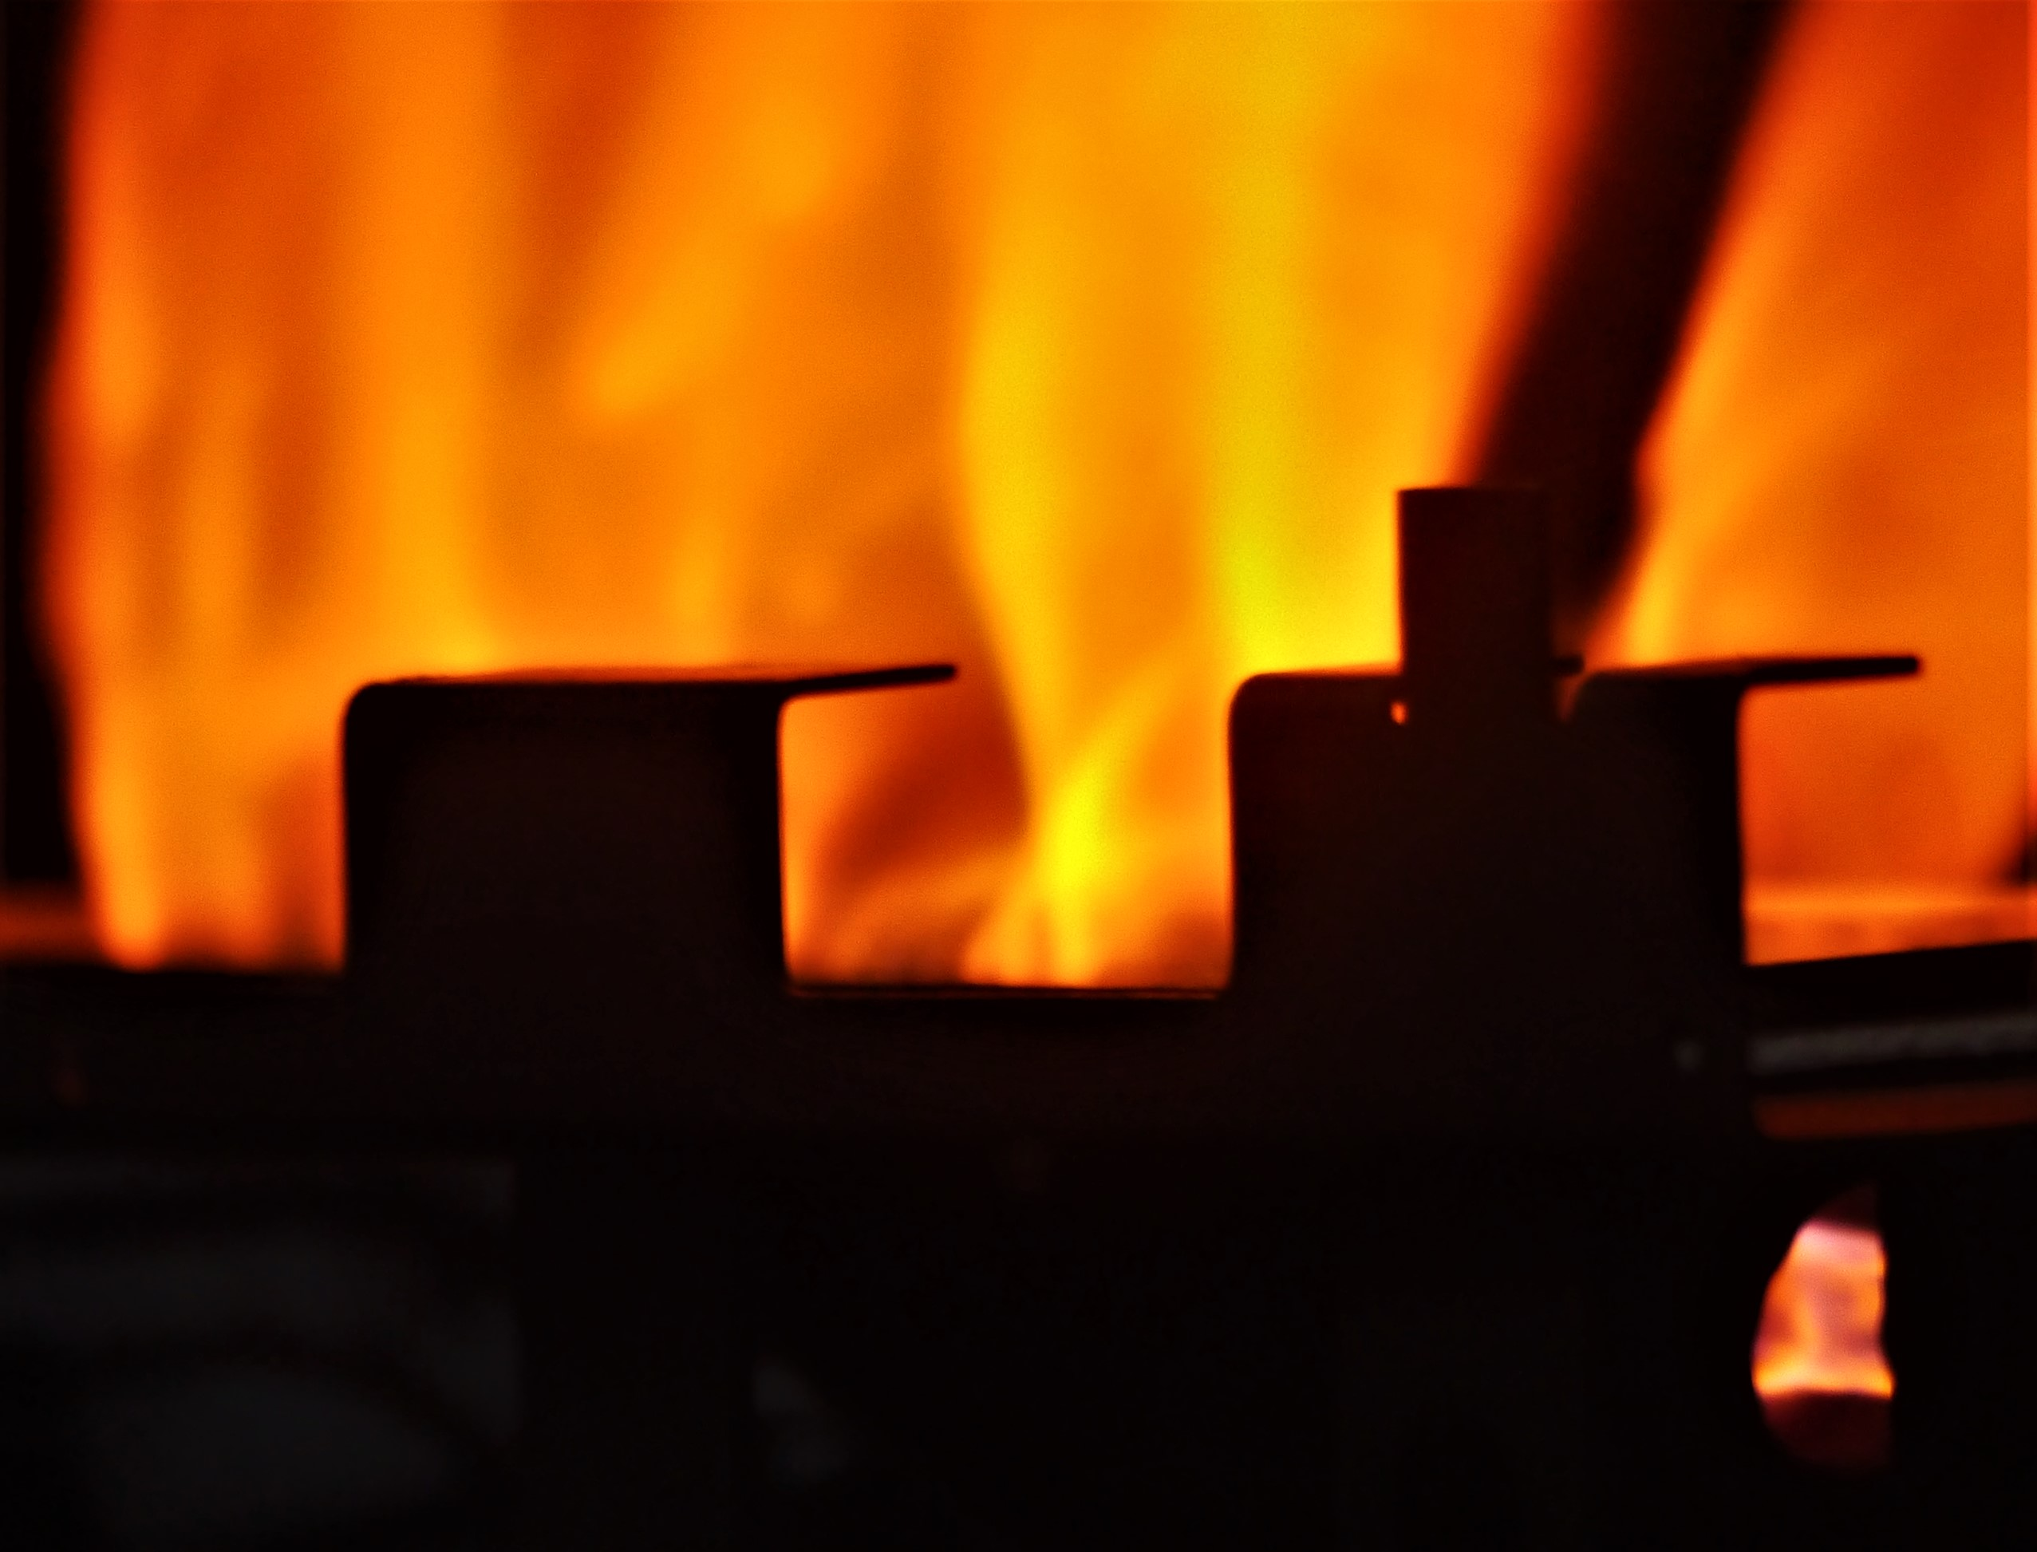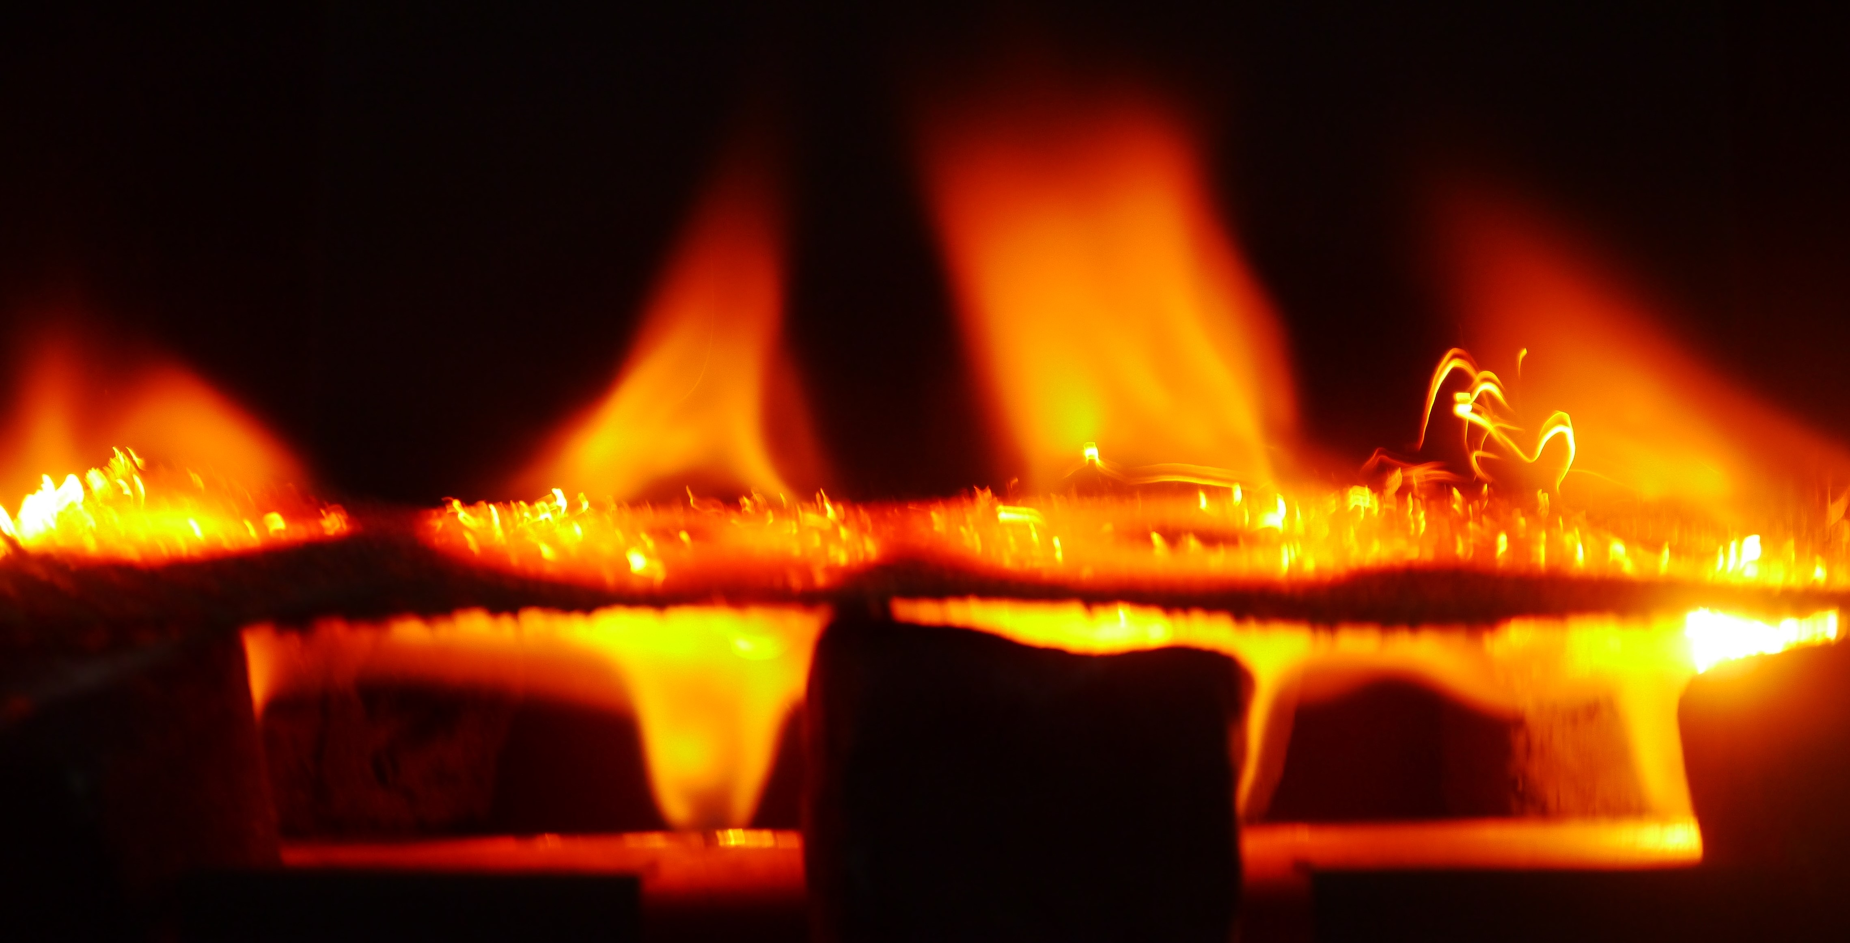
Figure 2: Premixed H₂ flame with flashback. Figure 3: CBS diffusion H₂ flame with mesh flame stabiliser.

emission bands in the ultraviolet, visible and infrared regions of the spectrum that result in a visible hydrogen flame. The visible blue emission was emphasized, which is a characteristic of lean burning premixed hydrogen/air flames. The premixed burner they used was operated at an equivalence ratio of 0.3 and was blue, but this is not a practical hydrogen burner. It is this blue colour that is often referred to in the literature.
The colour of a hydrogen flame on a diffusion burner is orange, the blue colour in a laboratory lean burning premixed flame is irrelevant, as no practical burner can be premixed because the flame will flashback. A premixed hydrogen/air flame using a premixed production gas fire, designed for NG, is shown in Fig. 2. This has clearly flash-backed as there is an orange diffusion flame attached to the premixed fuel inlet nozzle, on the lower right of Fig. 2. However, this premixed flame is also strongly orange. The reason for this is that in NG fire appliances the premixed section is designed to be richer than stoichiometric and the premixed flames entrain ambient air above the burner. Premixed rich flames are clearly strongly orange. Fig.3 shows the use of CBS Feccralloy wire mesh, which is commonly use in domestic central heating burners, with an array of hydrogen diffusion jets. The hydrogen diffusion flames have flashbacked to the gas jets below. Fig. 3 shows that the flame above and below the mesh is orange.
  - Hydrogen burners are less safe than Natural Gas burners (Fake Facts 3 – 8).
The most common fake fact about hydrogen burners is that they will be unsafe in use (Baxter, 2022) and the supply of the gas in homes will be unsafe (HyNot, 2022). This is Fake Fact 3, as after extensive study at the DNV Spadeadam explosion test site in the UK, it was concluded that hydrogen is as safe as natural gas to use in homes. This is provided that two excess flow shut off valves are used upstream and downstream of the gas meter (Arup and KIWA, 2021). These are already being retrofitted in the UK to NG users, as there is increased theft of copper gas pipes and gas meters, which leaves the gas supply pipe open, creating an explosion risk. The fake fact that the use of hydrogen in domestic heating and cooking would be unsafe was one of four fake facts mentioned by the UK Gov. Minister for Energy Security and Net Zero (Quinn, B. and Davies, R, 2023).
- The cost is too high (Fake Fact 4). The cost is much less than the cost of heat pump installations, which is why the sales of heat pumps are only 39,000 per year compared with 1.6M for gas boilers and 250,000 for gas fires. Natural gas appliances could rapidly be replaced with hydrogen/NG dual fuel appliances.
- There are concerns about safety, Fake Fact 3.
- That hydrogen boilers will not look like a NG boiler. The UK Government Hy4Heat project ensured there would be no differences in appearance or performance of hydrogen and NG appliances, which the industry has successfully demonstrated for gas boilers, fires and cookers. Fake Fact 5.
- “I don’t believe in telling people ‘Right, we’re just coming in to rip out your boiler to replace it with this other thing that you don’t want’. However, that is what is going to happen, if expensive heat pumps are forced into the domestic heat market, by removing low cost hydrogen gas heating as an option. Fake Fact 6.
The key findings from the DNV KIWA Gastec (2021) hydrogen risk assessment were as follows:
- Historic data shows that a significant cause of current fires and explosions is due to the absence of flame failure devices (FFDs), particularly on hobs. All hydrogen appliances will have FFDs.
- Small leaks (97% of reported leaks for NG are from holes no larger than two millimetres) do not create sufficiently large flammable clouds to produce injuries and all can be readily smelled.
- Medium sized leaks (from holes between three and seven millimetres in size) can produce flammable gas clouds in small rooms, notably those with the door closed and/or rooms with poor ventilation. These leaks are most often caused by third party damage. Leaks such as these rarely occur spontaneously.
- Large leaks (from holes greater than seven millimetres) are the size conventionally expected to produce high gas concentrations in large areas of a house. A significant percentage of these leaks arise from third party malicious intent. The introduction of two excess flow valves (EFVs), upstream and downstream of the gas meter, will reduce the likelihood of leaks developing into a hazardous scenario.
There is no evidence that hydrogen will leak more often than natural gas. 93% of explosions in houses with NG are due to large leaks mainly caused deliberately. If we exclude these, the risk of an explosion for NG and hydrogen is 1 in 10 million houses connected to the gas grid. The risk of explosions is similar to the risk of being hit by lightning or electrocuted by the house electrical supply system. Do we stop using electricity because a few people get electrocuted each year? No, we accept the small risk as the benefits of electricity supply outweigh the risk. Similarly, we know that bridges occasionally collapse, but that does not mean we should avoid bridges. The same should apply for hydrogen used for domestic heat, there is a risk of an explosion but no greater than the risk we already accept using NG in houses.
It is rarely mentioned by most anti-hydrogen lobbyist that death or injury risk with hydrogen is reduced relative to NG, due to the elimination of CO poisoning from faulty NG appliances. In 2020 there were 151 injuries from CO poisoning in houses compared with 35 fire/explosion incidents. From 2014 – 2020 there were 14 deaths from CO poisoning, compared with 11 from fire/explosions (Hy4Heat WP7 DNV KIWA, 2021). CO poisoning from NG use in domestic houses kills on average 2.3 people per year and injures 20 per year, compared with 1.8 deaths per year and 35 injuries from fire and explosions due to NG leaks. The CO deaths will be eliminated when using hydrogen for domestic heat and the explosion risks are no greater, so that hydrogen is a safer gas.
Fake Fact 7: hydrogen distributed in brittle cast iron pipes will leak hydrogen. This is true, but it is a fake fact because hydrogen will not be supplied through cast iron pipes as they are being replaced with yellow polyethyiene (PE) pipes. The leaks of NG are unacceptable and methane is a powerful greenhouse gas. The PE pipe replacement programme started in 2004 and will be completed in 2032. PE pipes do not crack and will not leak hydrogen. The expenditure on this is about £5Bn per year by the gas grid operators, paid for by consumers at about £100 per year, a total expenditure when complete of about £150bn.
One of the most common Fake Facts (No. 8) relating to safety, is that if there is a hole in a gas pipe then hydrogen will leak more gas and the explosion risk will be greater. This has never been true and the DNV/KIWA Gastec work (2021) has proved this. However, the common statement is made that hydrogen will leak at about three times the volume flow of NG and as the lean explosion limit of hydrogen is less than that of NG, the explosion risk will increase. The last fact is not true as in volume terms the lean limit of methane in air is 4.5% (Andrews and Bradley, 1972) and hydrogen lean limit is 4% and there is little difference in the explosion risk. However, although the volume flow leak of hydrogen through a hole in a pipe is about 3 times that of NG for the same upstream pressure, the mass flow leak is 1/3 of that of NG. The energy in hydrogen is about 3 x that of NG per kg and so the same energy is leaked, which is why the explosions are of a similar magnitude. The density of hydrogen is about 1/9 of that of NG and so the leaked fuel will rise 9 times faster due to buoyancy effects and hence will disperse more quickly, reducing the explosion risk for hydrogen. The Wobbe number of hydrogen and NG are similar, to within 6%, which is why a fuel hole with the same supply pressure will leak the same energy for both fuels. It is also why dual fuel hydrogen/NG burners can be used, as shown in the work of Andrews et al.(2024) for 70kW industrial burners.
Andrews et al. (2010) investigated massive leaks of hydrogen in a 50 m³ vessel that represented fracture of a large gas pipe in the enclosure. The hydrogen accumulated on the vessel ceiling and was stratified and even though if mixed it would not be flammable, the buoyancy effect led to a richer stratified ceiling layer that was flammable for 30 mins after initiating the massive hydrogen leak. To prevent this happening in buildings, excess flow valves are fitted to the gas supply, as demonstrated to be effective in the DNV/KIWA (2021) work. Very slow hydrogen releases from small hole leaks rise under buoyancy, mix with air and are not flammable at the ceiling layer; as found in the DNV/KIWA (2021) large scale tests.
  - Hydrogen burners have higher NO_{x} than NG burners: Fake Fact 9.
Lewis (2021) and Baxter (2022) have drawn attention to the potential problem of higher NO_{x} emissions from hydrogen combustion, which even if the emissions were equal to those of NG, the health consequences would still be a problem. Lewis (2021) says ‘Combustion applications therefore require optimisation and potentially lower hydrogen-specific emissions standards if the greatest air quality benefits are to derive from a growth in hydrogen use.’ This paper has been used by HyNot (2022) to say that NO₂ levels will be higher with hydrogen with adverse health effects. NO_{x} emissions from hydrogen flames are a matter of burner design, but as the stoichiometric flame temperature for hydrogen is higher than for NG, higher NO_{x} is possible. However, regulators are not proposing to allow hydrogen to emit more NO_{x} than NG. For balanced flue glass fronted gas fires we have demonstrated with hydrogen NO_{x} was 26 mg/kWh compared with the regulatory limit of 130 mg/kWh.
For the CBS Grid Cone design which used rich/lean low NO_{x} combustion, with orange hydrogen flames shown in Fig. 1, low NO_{x} can be achieved (Andrews et al.. 2024. For Grid Cone burners with 40 – 70 kW output, the hydrogen NO_{x} emissions were between 24 and 36% of those for NG. Also, the CBS Hy4Heat work on hydrogen fires showed it was possible to design hydrogen burners with NO_{x} emissions below those for operation on NG in a dual fuel mode. Both fuels were well inside the NO_{x} standard for NG fires. Thus, the concerns of Prof. Lewis are satisfied, hydrogen for heat can achieve reduced NO_{x} emissions.
  - Spontaneous Ignition of Hydrogen Due to the Joule Thompson Effect: Fake Fact 10.
Hydrogen has a negative Joule-Thomson coefficient under normal temperature and pressure (NTP) conditions. When hydrogen expands from high pressure to low pressure it heats up instead of cooling down, as most gases do, To be a hazard this effect would have to heat hydrogen to above the auto-ignition temperature of 510ºC. Astbury and Hawksworth (2007) concluded that the Joule–Thomson expansion is an unlikely ignition mechanisms for hydrogen. Li et al. (2023) modelled this effect and showed that the higher the pressure, the smaller the temperature rise after throttling and no risk of auto-ignition was predicted.
  - Conclusions
Practical hydrogen burner flames, including cooker hobs, are clearly visible and orange and not invisible. Hydrogen appliances and industrial burners are safe to use with the explosion risk similar to that of NG use, which is similar to the risk of being struck by lightning. Hydrogen is a safe fuel if the gas appliance regulations are met and the hydrogen supply has two excess flow valves fitted. Hydrogen leaks through small holes in a gas pipe are not more dangerous for hydrogen than NG as the energy leaked is the same, but the buoyant rise is greater for hydrogen. Hydrogen burner NO_{x} emissions will have to meet current regulations for NG and they can be designed to do this and can have lower NO_{x} than for NG. Hydrogen for heat is the best and lowest cost way to decarbonise heat, using the gas grid repurposed for hydrogen.

Acknowledgements
We would like to thank the UK Department of Energy Security and Net Zero, DESNZ (formerly BEIS) for three Hy4Heat contracts on gas fires. We would also like to thank CADENT, DNV and DESNZ for a contract on the influence of hydrogen impurities in gas fire and cooker hob applications. We would also like to thank DESNZ for a Green Distilleries contract GD166, where the 400kW and 1.5MW hydrogen burners shown in Figure 1 were developed. We are grateful to one of the referees for drawing our attention to Fake Fact 10.
References
Al Ghafri S.Z.S., Revell, C., Di Lorenzo, M., Ziao, G., Buckley, C.E., May, E.F. and John, M. (2022) Techno-economic and environmental assessment of LNG export for hydrogen production. International Journal of Hydrogen Energy, https://doi.org/10.1016/j.ijhydene. 2022.11.160.
Andrews, G.E. and Bradley, D. (1973). Limits of flammability and natural convection for methane-air mixtures, Proceedings of the Fourteenth Symposium on Combustion, pp.1119-1128.
Andrews, G.E., Mkpadi, M., Gardner, C. and Phylaktou, H.N. (2012). Explosions after the Sudden Release of Hydrogen into a Large Closed Volume where the Overall Mixture is not Flammable. IX ISHPMIE, International Symposium on Hazard, Prevention and Mitigation of Industrial Explosions. Cracow, Poland, 22-27 July 2012.
Andrews, G.E., Quinonez, R., Olanrewaju, F., Massey, R, Wakeman, R., Smith, S., Poon, J. and Phylaktou, H.N. (2024). Comparison of the NO_{x} emissions for a dual fuel hydrogen/NG industrial burner. INFUB 14. 14th Int. Conf. on Industrial Furnaces and Boilers, Algarve, Partugal, April 2024.
ARUP and KIWA Gastec (2021), Hy4Heat Safety Assessment Report Conclusions Report, incorporating Quantitative Risk Assessment. 1st May, 2021. ARP-WP7-GEN-REP-0005 This is the conclusions of 17 reports on aspects of H₂ safety.
Astbury, G.R. and Hawksworth, S.J. Spontaeous ignition of hydrogen:a review of postulated mechanisms.
Barrett, W.F. (1872). On certain phenomena associated with a hydrogen flame. Nature v.5, No. 129, p.482.
Baxter, T. (2022). https://www.thechemicalengineer.com/features/home-hydrogen-is-it-safe/
Clatti, S.A., Bihari, B. and Wallner, T. (2007). Establishing combustion temperature in a hydrogen fuelled engine using spectroscopic measurements. Proc. Inst. Mech. Eng. J. Automobile Eng., 221, 699-712).
Hawthorne, W.R., Weddell, D.S and Hottel, H.C. (1949), Mixing and Combustion in Turbulent Gas Jets. Third Symposium on Combustion, p.266 – 288, The Williams and Wilkinson Co., Baltimore.
HyNot, 2022. Leaflet distributed to residents of Whitby and Redcar to persuade them to oppose the hydrogen village trials funded by the UK Government. HyNot have a web site www,linktr..ee/hynot.
IEA, 2021. Net Zero by 2050. A roadmap for the global energy sector.
Lewis, A.C. (2021). Optimising air quality co-benefits in a hydrogen economy: a case for hydrogen-specific standards for NOx emissions. Environ. Sci: Atmos,2021,1,201.
Li, J-Q, Chen.Y., Ma, Y-B, Kwon, J-T, Xu,H. and Li.J-C (2023). A study on the Houle Thompson effect during filling hydrogen in high pressure tests. Case Studies in Thermal Engineering 41, 102678.
Livermore, S., McGlip, A. and McNanpt, D. Appraisal of Domestic Hydrogen Appliances, (2018). Frazer Nash Consultancy report for UK BEIS. FNC 55089 146433R Issue 1.
Lowe, G., Brancaccio, N., Batten, D., Long, C., Weibel, D. (2011). Technology assessment of hydrogen firing of process heaters. Energy Procedia 4, 1058-1065.
Mohanna, H., Mouriot, Y., Laillat, S., Sedmak, P., Chirsaz, R and Lesre, L. Hydrogen combustion burner for non-oxidising furnaces in steel processing lines. INFUB 14, April, 2024.
Patel, J., Mulvany, K., Devaray, D. and Andrews, T. Hydrogen Costs. Cornwall Insight, 2.9.22.

Rosenow, J. Is heating homes with hydrogen all but a pipe dream? An evidence review, Joule (2022), https:// doi.org/10.1016/j.joule.2022.08.015

Quinn, B. and Davies, R. (2023). Hydrogen boiler plan likely to be dropped says Shapps. The Guardian, 14.7.23.

Schafer, R.W. et al. (2009), Visible emission of hydrogen flames, Combustion and Flame, Pages 1234-1241.
Taylor, R. (May 2021). Options for a UK low carbon hydrogen standard. BEIS and E4Tech, UK Government.
UK Dept. Energy Security and Net Zero (DESNZ) (2022), “Digest of UK Energy Statistics 2022”

